ACCESSION NO: 2019-0034

ALASKA DEPARTMENT OF FISH AND GAME
Division of Commercial Fisheries - FISH PATHOLOGY SECTION
333 RASPBERRY ROAD, ANCHORAGE, AK 99518-1599 - Phone (907) 267-2244/Fax 267-2194

REPORT OF LABORATORY EXAMINATION

LOT (YEAR, STOCK, SPECIES): Shishmaref rainbow smelt, Osmerus mordax

FACILITY: Private Citizen

CONTACT PERSON/ADDRESS: Omitted for confidentiality

SAMPLE DATE: ~1/25/19 DATE SAMPLE RECEIVED: 2/8/19

SPECIMEN TYPE: Whole fish LIFE STAGE: Adult WILD: Yes

NUMBER OF SAMPLES: 15 STATE: Frozen

HISTORY/SIGNS: The Fish Pathology Laboratory in Anchorage was contacted by Fish and Game Biologists in Nome, LEO Network administrators, and employees of Kawerak, Inc. regarding recently caught smelt from the area that smelled and tasted abnormal. Shortly after, a resident from Anchorage with family in Nome submitted a bag of frozen fish that had been caught 3 weeks earlier. These fish were reported to also have an off-flavor and smell, which was described as similar to exhaust fumes. Her mother had eaten some of these fish and became sick with gastrointestinal symptoms. She was admitted to a local hospital for treatment where she remained for 5 days due to complications regarding her elderly age and these symptoms. Also noted was an oily sheen on the water near the lagoon side of the fishing area where these fish were caught.

REASON FOR SUBMISSION: Diagnostic evaluation for an infectious agent or tissue pathology

FINAL REPORT DATE: 2/13/19

CLINICAL FINDINGS
NECROPSY:

Fish were identified as rainbow smelt, Osmerus mordax, based on key diagnostic features in Mecklenburg et al., 2002, such as the maxilla extending to the posterior part of the eye, one large canine on each side of the vomer, and prominent conical to caniniform teeth on the tongue. The fish that was examined measured approximately 25 cm in fork length and did not display any abnormalities externally or internally (Figures 1 and 2). This fish was a sexually mature female based on the presence of ripe ovaries (Figure 2). There were no remarkable findings from gill wet mounts, skin scrapes, or squashes of spleen, airbladder, or gut. The peripheral blood smear was also not remarkable.

The fish did have an unnatural smell that could be described as a strong, sweet, organic odor. The scent was most concentrated on the exterior of the fish, presumably in the slime, skin, and flesh. The visceral cavity did not emit the odor strongly, if at all, as it had a more natural fishy smell.

DIAGNOSIS: Apparently healthy fish; no signs of fish disease. Unnatural odor likely a chemical obtained from the environment or through the food chain.

COMMENTS/RECOMMENDATIONS: There were no clinical signs of disease in the fish that were submitted. Therefore the strong, unnatural odor is likely due to a chemical that the fish has come into contact with or has assimilated into the body through the food chain.

A somewhat similar phenomenon has been reported in the literature that involves dimethyl sulfide or DMS causing an oily flavor in fish. DMS is proposed as the byproduct of fish consuming sea snails of the species Limacina helicina that feed on marine algae. Fermentation of the snail occurs in the gut and then compounds concentrate in the muscle of some herbivorous fish, including chum salmon. Low levels of DMS occur in asparagus, cabbage, corn, and seafood when cooked, but there have been no reports of foodborne illness associated with this compound. However, there could be a dose response where high levels could produce clinical disease.

The remaining frozen fish were sent to DEC for organoleptic testing and potentially other tests to determine the compound responsible for this condition.

FISH HEALTH INVESTIGATOR: J. Ferguson
TECHNICAL ASSISTANCE: B. Ockerman, D. Stewart

COPIES TO: FY19, Misc, Gerlach (DEC), Brubaker (ANTHC), Sheffield (UAF), Ahmasuk (Kawerak), Lee (NSHC), Leon, Vercessi, Rozen, Davis, Meyers

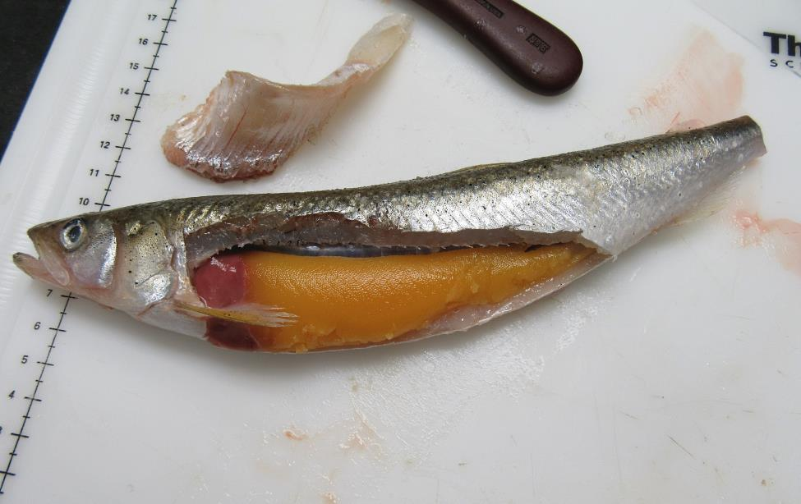
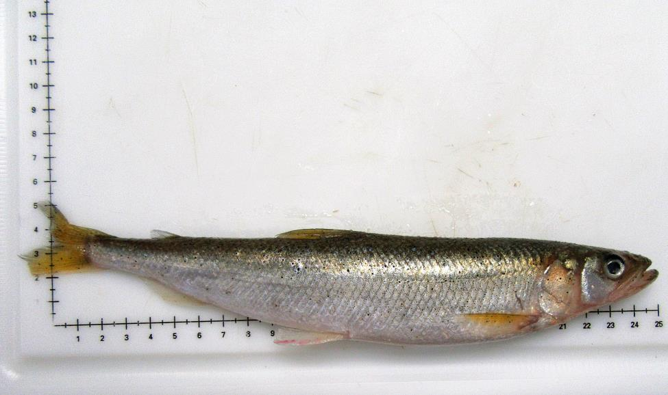
Figure 1. Exterior presentation of rainbow smelt in present case. No abnormalities or signs of disease are exhibited.
Figure 2. Interior presentation of rainbow smelt in present case. No abnormalities or signs of disease are exhibited. The large yellow-orange organs occupying the majority of the visceral cavity are the ovaries

